**Table 1. Descriptive statistics.**

|  | Total  (N=366) | Buiten_regio (N=62) | EMC_na2017 (N=110) | EMC_voor2017 (N=116) | Regio  (N=78) |
| --- | --- | --- | --- | --- | --- |
| **Hypoparathyroidism** | 44 (12.0%) | 12 (19.4%) | 9 (8.2%) | 15 (12.9%) | 8 (10.3%) |
| **PTH at baseline** |  |  |  |  |  |
| Mean (SD) | 4.4 (2.3) | 4.5 (2.1) | 3.1 (1.9) | 4.7 (1.7) | 5.6 (3.0) |
| Median (Q1, Q3) | 4.0 (2.7, 5.5) | 4.2 (3.2, 5.2) | 2.5 (2.0, 3.7) | 4.6 (3.7, 5.5) | 5.3 (3.6, 7.2) |
| Min - Max | 0.3 - 15.9 | 1.0 - 13.8 | 0.5 - 13.0 | 1.1 - 10.8 | 0.3 - 15.9 |
| Missing | 19 | 0 | 6 | 4 | 9 |
| **PTH at 24 hours** |  |  |  |  |  |
| Mean (SD) | 1.7 (1.3) | 1.8 (1.3) | 1.2 (1.0) | 1.7 (1.2) | 2.2 (1.7) |
| Median (Q1, Q3) | 1.4 (0.5, 2.4) | 1.6 (0.7, 2.7) | 1.1 (0.5, 1.6) | 1.5 (0.6, 2.6) | 2.1 (0.6, 3.3) |
| Min - Max | 0.1 - 8.0 | 0.1 - 5.4 | 0.1 - 4.5 | 0.4 - 4.9 | 0.3 - 8.0 |
| Missing | 28 | 0 | 7 | 11 | 10 |
| **Delta PTH** |  |  |  |  |  |
| Mean (SD) | 55.4 (38.0) | 53.6 (44.0) | 53.4 (45.8) | 59.6 (28.6) | 53.3 (30.9) |
| Median (Q1, Q3) | 60.4 (35.9, 84.7) | 61.8 (30.2, 84.4) | 61.0 (38.9, 86.1) | 64.3 (36.0, 85.2) | 58.1 (38.4, 79.4) |
| Min - Max | -220.0 - 98.4 | -171.4 - 98.0 | -220.0 - 98.4 | -17.4 - 96.3 | -29.2 - 97.0 |
| Missing | 47 | 0 | 13 | 15 | 19 |
| **Calcium at baseline** |  |  |  |  |  |
| Mean (SD) | 2.4 (0.1) | 2.4 (0.1) | 2.4 (0.1) | 2.4 (0.1) | 2.3 (0.1) |
| Median (Q1, Q3) | 2.4 (2.3, 2.4) | 2.4 (2.3, 2.5) | 2.4 (2.3, 2.4) | 2.4 (2.3, 2.4) | 2.4 (2.2, 2.4) |
| Min - Max | 2.1 - 3.0 | 2.1 - 3.0 | 2.2 - 2.7 | 2.1 - 2.6 | 2.1 - 2.6 |
| Missing | 25 | 0 | 3 | 6 | 16 |
| **Albumine at baseline** |  |  |  |  |  |
| Mean (SD) | 42.8 (4.2) | 43.3 (3.9) | 42.7 (4.5) | 44.3 (3.2) | 39.8 (3.9) |
| Median (Q1, Q3) | 43.0 (40.0, 46.0) | 44.0 (41.0, 46.0) | 44.0 (40.0, 46.0) | 44.0 (42.0, 47.0) | 39.0 (37.5, 43.0) |
| Min - Max | 30.0 - 51.0 | 35.0 - 51.0 | 30.0 - 51.0 | 35.0 - 51.0 | 31.0 - 49.0 |
| Missing | 20 | 0 | 3 | 6 | 11 |
| **Corrected calcium at basline** |  |  |  |  |  |
| Mean (SD) | 2.2 (0.1) | 2.3 (0.1) | 2.3 (0.1) | 2.2 (0.1) | 2.2 (0.1) |
| Median (Q1, Q3) | 2.2 (2.2, 2.3) | 2.3 (2.2, 2.3) | 2.2 (2.2, 2.3) | 2.2 (2.1, 2.2) | 2.2 (2.2, 2.3) |
| Min - Max | 2.0 - 2.8 | 2.1 - 2.8 | 2.0 - 2.7 | 2.0 - 2.4 | 2.0 - 2.5 |
| Missing | 27 | 0 | 3 | 6 | 18 |
| **Calcium at 24 hours** |  |  |  |  |  |
| Mean (SD) | 2.1 (0.1) | 2.1 (0.2) | 2.1 (0.1) | 2.1 (0.1) | 2.1 (0.2) |
| Median (Q1, Q3) | 2.1 (2.0, 2.2) | 2.1 (2.0, 2.3) | 2.1 (2.0, 2.2) | 2.1 (2.0, 2.2) | 2.1 (2.1, 2.2) |
| Min - Max | 1.7 - 2.6 | 1.8 - 2.4 | 1.7 - 2.6 | 1.7 - 2.5 | 1.7 - 2.4 |
| Missing | 9 | 0 | 0 | 7 | 2 |
| **Albu at 24 hours** |  |  |  |  |  |
| Mean (SD) | 37.5 (4.8) | 37.2 (3.0) | 37.2 (5.6) | 39.2 (4.7) | 35.8 (4.0) |
| Median (Q1, Q3) | 38.0 (35.0, 40.0) | 37.0 (35.0, 39.0) | 38.0 (35.0, 41.0) | 40.0 (38.0, 41.0) | 36.0 (33.0, 39.0) |
| Min - Max | 0.8 - 48.0 | 31.0 - 48.0 | 0.8 - 46.0 | 2.2 - 47.0 | 27.0 - 45.0 |
| Missing | 14 | 5 | 0 | 7 | 2 |
| **Corrected calcium at 24 hours** |  |  |  |  |  |
| Mean (SD) | 2.1 (0.2) | 2.1 (0.1) | 2.1 (0.2) | 2.0 (0.1) | 2.1 (0.2) |
| Median (Q1, Q3) | 2.1 (2.0, 2.2) | 2.0 (1.9, 2.2) | 2.1 (2.0, 2.2) | 2.0 (1.9, 2.1) | 2.1 (2.0, 2.2) |
| Min - Max | 1.6 - 2.7 | 1.7 - 2.4 | 1.7 - 2.7 | 1.7 - 2.7 | 1.6 - 2.4 |
| Missing | 14 | 5 | 0 | 7 | 2 |
| **Delta corrected calcium** |  |  |  |  |  |
| Mean (SD) | 7.6 (6.5) | 8.6 (6.6) | 7.9 (6.5) | 7.6 (6.9) | 6.4 (5.7) |
| Median (Q1, Q3) | 7.3 (4.1, 11.7) | 8.3 (4.5, 12.6) | 8.2 (4.7, 11.5) | 7.6 (4.2, 12.1) | 6.1 (3.0, 9.1) |
| Min - Max | -29.8 - 23.1 | -6.0 - 23.1 | -27.7 - 21.0 | -29.8 - 22.5 | -5.5 - 18.0 |
| Missing | 33 | 5 | 3 | 7 | 18 |
| **Delta calcium** |  |  |  |  |  |
| Mean (SD) | 10.6 (6.2) | 11.7 (7.2) | 11.0 (6.0) | 10.6 (6.1) | 9.1 (5.6) |
| Median (Q1, Q3) | 10.1 (6.7, 14.2) | 11.7 (6.7, 17.0) | 10.8 (8.1, 14.5) | 10.0 (6.7, 13.8) | 8.9 (6.3, 12.4) |
| Min - Max | -8.4 - 27.0 | -8.4 - 27.0 | -3.5 - 25.1 | -3.4 - 25.7 | -6.6 - 22.1 |
| Missing | 26 | 0 | 3 | 7 | 16 |
| **Age in years**  Median (Q1, Q3) | 56.0  (42.0, 69.0) | 58.0  (46.2, 72.0) | 56.0  (40.0, 66.8) | 60.0  (48.0, 73.0) | 52.0  (40.0, 61.8) |
| **Males** | 117 (32.0%) | 25 (40.3%) | 52 (47.3%) | 31 (26.7%) | 9 (11.5%) |
| **Surgery type** |  |  |  |  |  |
| Completion | 74 (20.2%) | 11 (17.7%) | 15 (13.6%) | 23 (19.8%) | 25 (32.1%) |
| Total | 292 (79.8%) | 51 (82.3%) | 95 (86.4%) | 93 (80.2%) | 53 (67.9%) |
| **BSK not seen** | 48 (13.8%) | 3 (4.8%) | 9 (8.5%) | 20 (18.9%) | 16 (21.9%) |
| **CHKD = “Yes”** | 112 (31.2%) | 17 (27.4%) | 57 (52.8%) | 33 (29.2%) | 5 (6.6%) |

Abbreviations: PTH, **?**; Delta PTH, (PTH at baseline – PTH at 24 hours)/(PTH at baseline)*100; CorrCa, Calcium + (34 – Albu)*0.016; delta CorrCa, (CorrCa at baseline – CorrCa at 24 hours)/(CorrCa at baseline)*100; delta calcium, (calcium at baseline – calcium at 24 hours)/(calcium at baseline)*100; BSK, bijschildklier; CHKD, centrale halsklier dissectie.

**Table 2. Full, final, and simple model predicting hypoparathyroidism with a uniform shrinkage factor of 0.874**. Table displays odds ratios and the 95% confidence intervals of the logistic regression model predicting the probability of hypoparathyroidism. The final model is selected using backward selection with p-values < 0.05.

|  |  |  |  |  |  |  |  |  |  |  |  |
| --- | --- | --- | --- | --- | --- | --- | --- | --- | --- | --- | --- |
|  | Full model | | |  | Final model | | |  | Simple model | | |
|  | OR | 95% CI | Imp. |  | OR | 95% CI | Imp. |  | OR | 95% CI | Imp. |
| Intercept | 1.394 | [0.003; 642.516] |  |  | 1.068 | [0.003; 427.952] |  |  | 0.000 | [0.000; 0.004] |  |
| ΔPTH  (1% increase) | 1.085 | [1.034; 1.114] | 18.2 |  | 1.085 | [1.035; 1.113] | 19.3 |  | 1.089 | [1.042; 1.114] | 25.2 |
| CorrCa24u  (0.2 versus 0.1) | 1.458 | [0.112; 17.271] | 8.6 |  | 1.426 | [0.121; 15.428] | 8.2 |  |  |  |  |
| BSK seen | 3.479 | [2.906; 3.042] | 7.2 |  | 3.778 | [1.335; 7.648] | 8.9 |  |  |  |  |
| Age in years  (i.q.r. 69 versus 42 years) | 1.157 | [0.456; 2.827] | 0.2 |  |  |  |  |  |  |  |  |
| Males versus females | 0.999 | [0.480; 2.081] | 0.0 |  |  |  |  |  |  |  |  |
| Completion surgery versus total | 1.484 | [0.420; 4.745] | 0.4 |  |  |  |  |  |  |  |  |
| CHKD = Yes versus No | 1.379 | [0.626; 2.804] | 0.7 |  |  |  |  |  |  |  |  |
| *C-index\** | 0.888 | [0.853; 0.924] |  |  | 0.887 | [0.850; 0.925] |  |  | 0.856 | [0.813; 0.900] |  |

*The C-index is corrected for optimism by bootstrapping. Abbreviations: OR, odds ratio; CI, confidence interval, Imp., importance defined by the Chi-square of the Wald-statistic; ΔPTH, (PTH at baseline – PTH at 24 hours)/(PTH at baseline)*100; CorrCa24u, (corrected calcium at baseline – corrected calcium at 24 hours)/(corrected calcium at baseline)*100.

Likelihood ratio test of final model versus simple model is $χ^{2}=18.0;p<0.001$.

Likelihood ratio test of full model versus final model is $χ^{2}=1.3;p<0.869$.

**Table 3. $Δ$ PTH and readmission**. ΔPTH is averaged over the five imputed data sets, i.e., if the majority of the imputations indicates ΔPTH > 70%.

|  |  |  |
| --- | --- | --- |
|  | $Δ$ PTH $≤$ 70% | $Δ$ PTH > 70% |
| No readmission | 208 | 131 |
| Readmission | 0 | 27 |

**Table 4. Predictions of hypothyroidism and readmission for all patients**. The predictions are averaged over the five imputed data sets.

|  |  |  |  |  |  |
| --- | --- | --- | --- | --- | --- |
|  | Predicted probability of hypoparathyroidism | | | | |
|  | p < 10% |  | 10% ≤ p ≤ 30% |  | p > 30% |
| N | 213 |  | 74 |  | 61 |
| No readmission | 229 (99.1%) |  | 67 (90.5%) |  | 43 (70.5%) |
| Readmission | 2 (0.9%) |  | 7 (9.5%) |  | 18 (29.5%) |

**Figure 1. Internal-external model performance of the final model**.

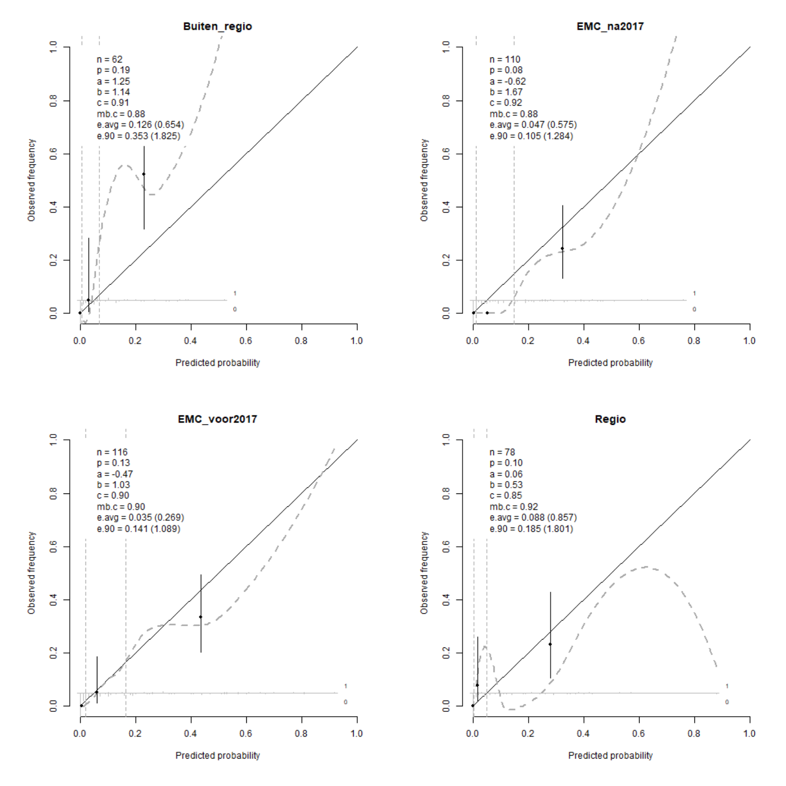

**Supplemental Figure 1. Model performance of models uncorrected for optimism**.

|  |  |
| --- | --- |
| Full model | Final model |
| Z:\Project Predict Hypoparathyroidism\Results\model.performance.full.model.png | Z:\Project Predict Hypoparathyroidism\Results\model.performance.final.model.png |
| Simple model |  |
| Z:\Project Predict Hypoparathyroidism\Results\model.performance.simple.model.png |  |

**Supplemental figure 2. Plot predict of flexible model without shrinkage, i.e., PTH, calcium, and age modelled with restricted cubic splines with three degrees of freedom.**

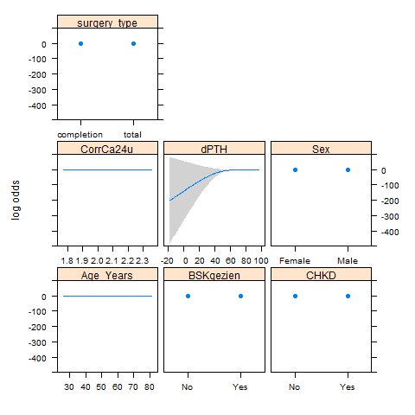

**Functional form of full model**

$$\log\left(\frac{p_{i}}{1-p_{i}}\right)=β_{0} \\ +β_{1}⋅ΔPTH \\ +β_{2}⋅BSK niet gezien \\ +β_{3}⋅CorrCa24hrs \\ +β_{3}⋅Age \\ +β_{4}⋅Male \\ +β_{5}⋅Completion surgery \\ +β_{6}⋅CHKD$$

with $ΔPTH=\frac{PTH at baseline-PTH at 24 hours}{PTH at baseline}⋅100$, and CorrCa24hrs=Calcium at 24 hours+0.016⋅(34-Albu at 24 hours).

**Functional form of final model without shrinkage**

$$\log\left(\frac{p_{i}}{1-p_{i}}\right)=β_{0} \\ +β_{1}⋅ΔPTH \\ +β_{2}⋅BSK niet gezien \\ +β_{3}⋅CorrCa24hrs$$

with $ΔPTH=\frac{PTH at baseline-PTH at 24 hours}{PTH at baseline}⋅100$, and CorrCa24hrs=Calcium at 24 hours+0.016⋅(34-Albu at 24 hours).

**Supplemental table 1. Comparison of functional form of PTH and calcium in the full model.**

|  |  |  |
| --- | --- | --- |
| Functional form of PTH | Functional form of Calcium | AIC |
| PTH24u | Ca24u | 217.5 |
| PTH24u | CorrCa24u | 212.6 |
| PTH24u | dCa24u | 223.9 |
| PTH24u | dCorrCa24u | 220.8 |
| ΔPTH | Ca24u | 193.6 |
| **ΔPTH** | **CorrCa24u** | **190.5** |
| ΔPTH | dCa24u | 197.5 |
| ΔPTH | dCorrCa24u | 195.8 |

**Supplemental table 2. Flexibility of ΔPTH, calcium, and age in the full model.**

|  |  |  |  |
| --- | --- | --- | --- |
| ΔPTH | Corrected calcium | Age | AIC |
| ΔPTH | CorrCa24u | Age | 190.5 |
| rcs(ΔPTH, 3) | CorrCa24u | Age | 191.6 |
| **rcs(ΔPTH, 4)** | **CorrCa24u** | **Age** | **190.3** |
| rcs(ΔPTH, 5) | CorrCa24u | Age | 191.8 |
| ΔPTH | rcs(CorrCa24u, 3) | Age | 192.0 |
| ΔPTH | rcs(CorrCa24u, 4) | Age | 193.9 |
| ΔPTH | rcs(CorrCa24u, 5) | Age | 195.8 |
| ΔPTH | CorrCa24u | rcs(Age_Years, 3) | 191.3 |
| ΔPTH | CorrCa24u | rcs(Age_Years, 4) | 193.2 |
| ΔPTH | CorrCa24u | rcs(Age_Years, 5) | 192.1 |
| rcs(ΔPTH, 4) | rcs(CorrCa24u, 3) | Age | 192.0 |
| rcs(ΔPTH, 4) | CorrCa24u | rcs(Age_Years, 3) | 191.2 |
| ΔPTH | rcs(CorrCa24u, 3) | rcs(Age_Years, 3) | 192.6 |
| rcs(ΔPTH, 4) | rcs(CorrCa24u, 3) | rcs(Age_Years, 3) | 192.8 |

Likelihood ratio test of best flexible model versus rigid model $χ^{2}=4.2;p=0.124$.